**WEB ENGINEERING (CT-362)**

Assignment 1

**MEMBERS:**

1. Syed Annas Jawed (CT-039)
2. Syed Ehsan Nadeem (CT-041)
3. Muhammad Usman (CT-059)

**DEPARTMENT:** BCIT

**YEAR:** SCIT

**TASK:**

Perform system modeling on proposed Web Application. Develop the following models using UML and UWE notations:

1. Requirement Model (Use case diagram, Activity diagram)
2. Content Model (class diagram, State machine diagram)
3. Navigation model
4. Presentation Model

**NOBLE NON-PROFIT**

**REASONS FOR DOING THIS APPLICATION**

* Foundations of connections build by the software between organization and users (donors) through online donation which would save time of donors where they can donate easily from anywhere.
* It will also offer delivery where the donor can enter his/her details and the volunteers can collect the things from them and transport it to a particular organization.
* The organizations would be able to access the website where they could mention the facilities they are providing to deprived people and can also add the things needed further by them.

OUR GOALS

As helping humanity is an important and recommended act from ALLAH to maintain stability of wealth among poor and rich. So, our goal is to minimize the difference between rich and poor and to provide easy resources of donations, because sometimes people want to donate but due to lack of easy resources their help demolished

BENEFITS

There are number of benefits of this charity based system.some are :

* Donate blood for thalassemia patients
* Donate blankets for needy people
* Donate financial help regarding studies , medicines and many more.
* Celebrating birthdays with old and orphans.
* Donate used and new clothes to organizations.
* Donate food for daily or monthly bases.
* Collect unused makeup and donate at the centre of abused women
* Help deliver gifts and meals to the patients at hospital.
* Fulfilling last wishes of people of old home.

· etc and many more related options

**REQUIREMENT MODEL**

Use case diagram:

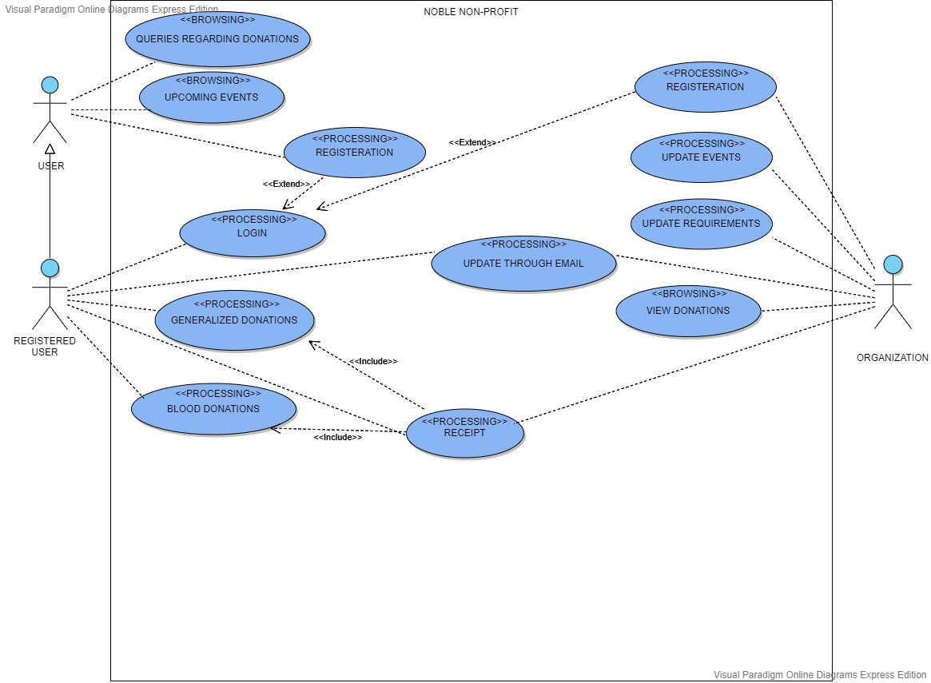

Activity diagram:

FOR ADMIN :

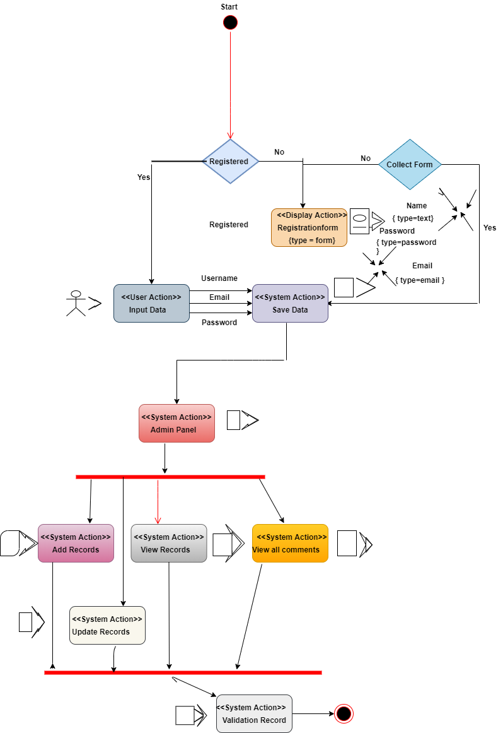 **FOR DONOR** :

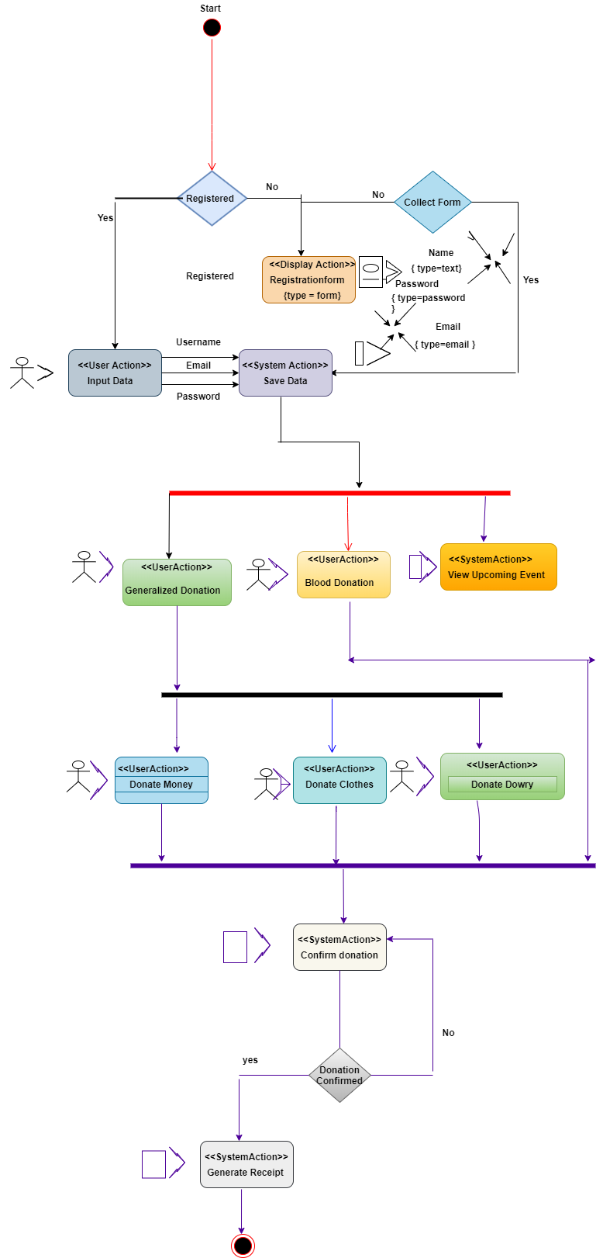

**CONTENT MODEL**

Class diagram:

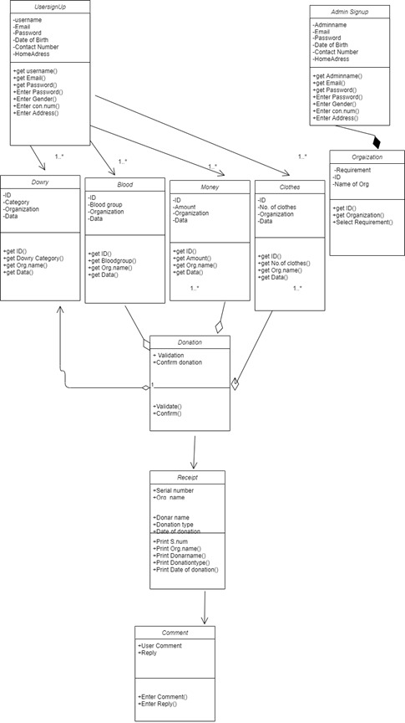

State Machine diagram:

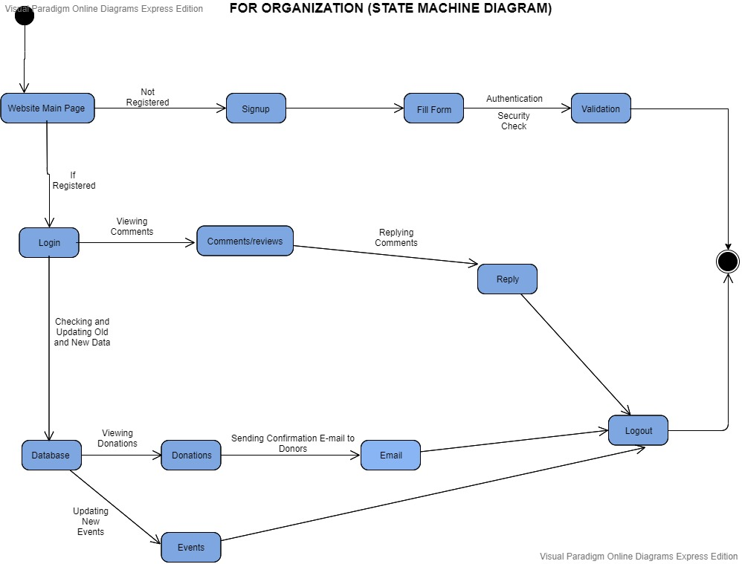

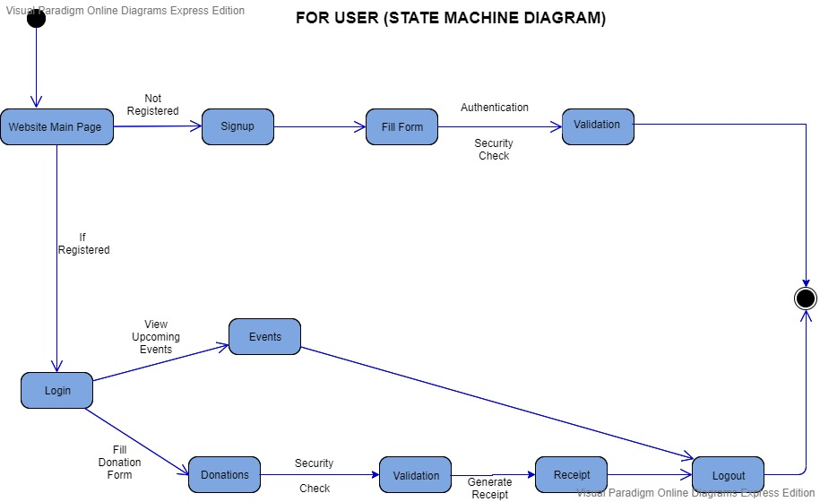

**NAVIGATION MODEL**

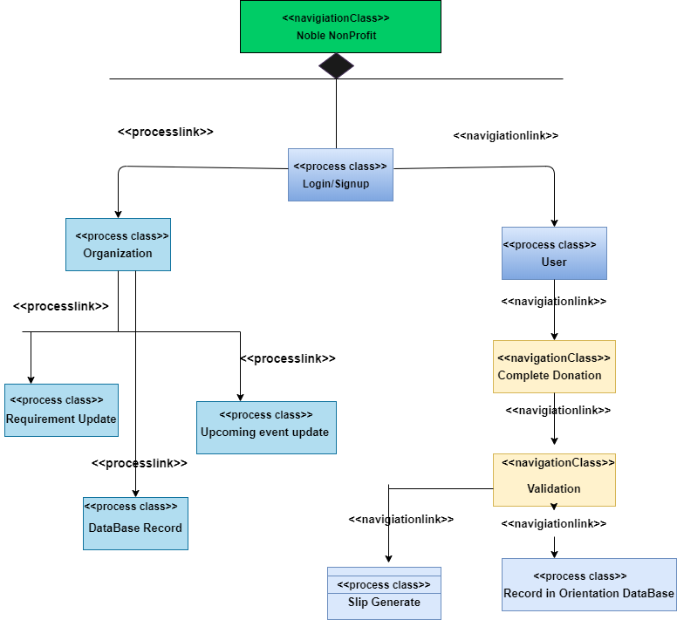

**PRESENTATION MODEL**

**FOR HOME PAGE :**

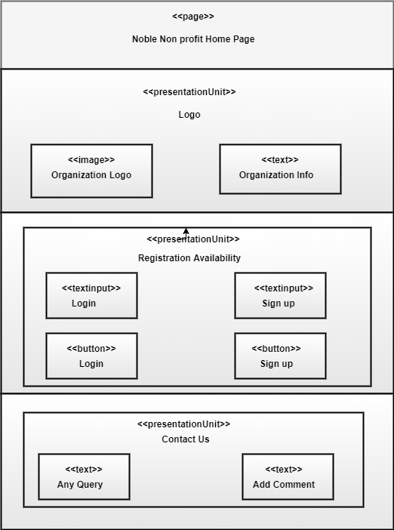

**ADMIN PAGE :**

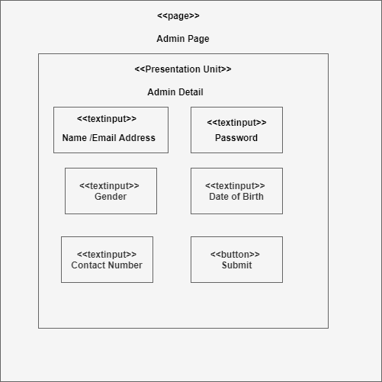

**FOR BLOOD DONATION :**

